**Lesson 4 Demo 10**

**How to Use INDEX and OFFSET Function**



**Steps to be followed:**

**Step 1: Open the Excel file**

* 1. Open the file named **Index,Offset,Match.xlsx**

**Step 2: Using INDEX function in Excel**

2.1 The data to perform INDEX is given below

2.2 Enter the column number of Profit/Loss in Cell E3

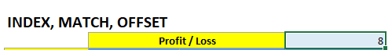

2.3 Enter the following formula in C5 and copy it to column C

=INDEX($B$17:$I$1342,E5,$E$3)

2.4 Enter the following formula in D5 and copy it to column D

=OFFSET($B$17,E5-1,$E$3-1)

2.5 The final table with index, match, and offset will look like this

